SAREF extension for Automotive
Review

- Introduction and context
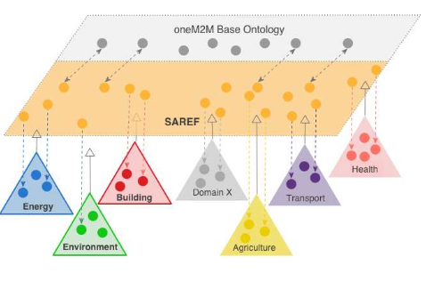

Smart Appliances REFerence ontology (SAREF) as “interoperability language” in cross-domain IoT ecosystems with several verticals: Smart Cities, Smart AgriFood, Smart Industry & Manufacturing, Automotive, eHealth/Ageing-well and Wearables.
The core SAREF ontology (https://w3id.org/saref) imports the W3C time ontology, and defines devices with there states, properties, functions, controls… With 15 classes and 82 properties, it is not a lightweight domain-independant ontology (larger than the W3C SSN/SOSA ontologies for instance).
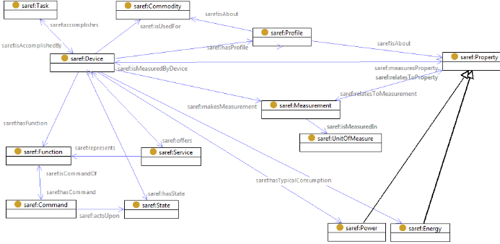
SAREF has extensions for specific domains such as the energy domain (http://saref.linkeddata.es/).
- SAREF4AUTO
SAREF4AUTO is an extension dedicated to the automotive domain (https://portal.etsi.org/STF/STFs/STFHomePages/STF566).
- Requirements
They reused the work of existing consortium and European projects: AIOTI,OneM2M, ETSI TC ITS, DATEX-II, Sensoris, W3C Automotive Ontology Group, H2020 Autopilot, H2020 SINCHRONICITY, ENSEMBLE, TransAID.
Use cases include:
- Platooning
- Automated Valet Parking (AVP)
- Cooperative Perception Service (CPS)
- Vulnerable Road Users (VRUs)

  - Evaluation
To evaluate SAREF4AUTO, competency questions are stated, for instance:
- What type of vehicles are there?
- What are critical objects?
- What is the overall shape of an entity?
Those question come from practical requirement expressed by experts of the given se cases and will be used as a metric of the domain coverage of the ontology extension.

- Release:
The SAREF4AUTO ontology is planned to be delivered in June 2020 as an ETSI Technical Specification

